Here’s a clear, realistic hierarchy of Indriya (Novel Jewels) inside the Aditya Birla Group — based on how large retail ventures like this are actually structured.

🏗️ INDriya (Novel Jewels) — ORGANIZATION HIERARCHY

🧭 1. Group-Level Leadership (Strategic Control)
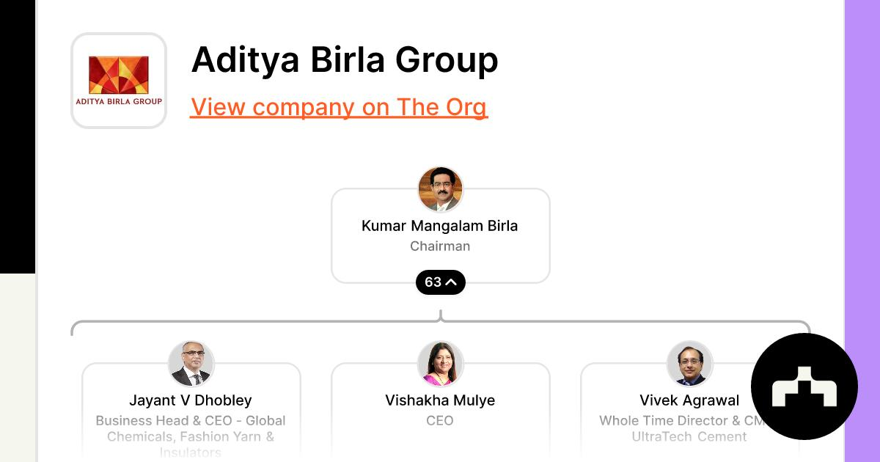
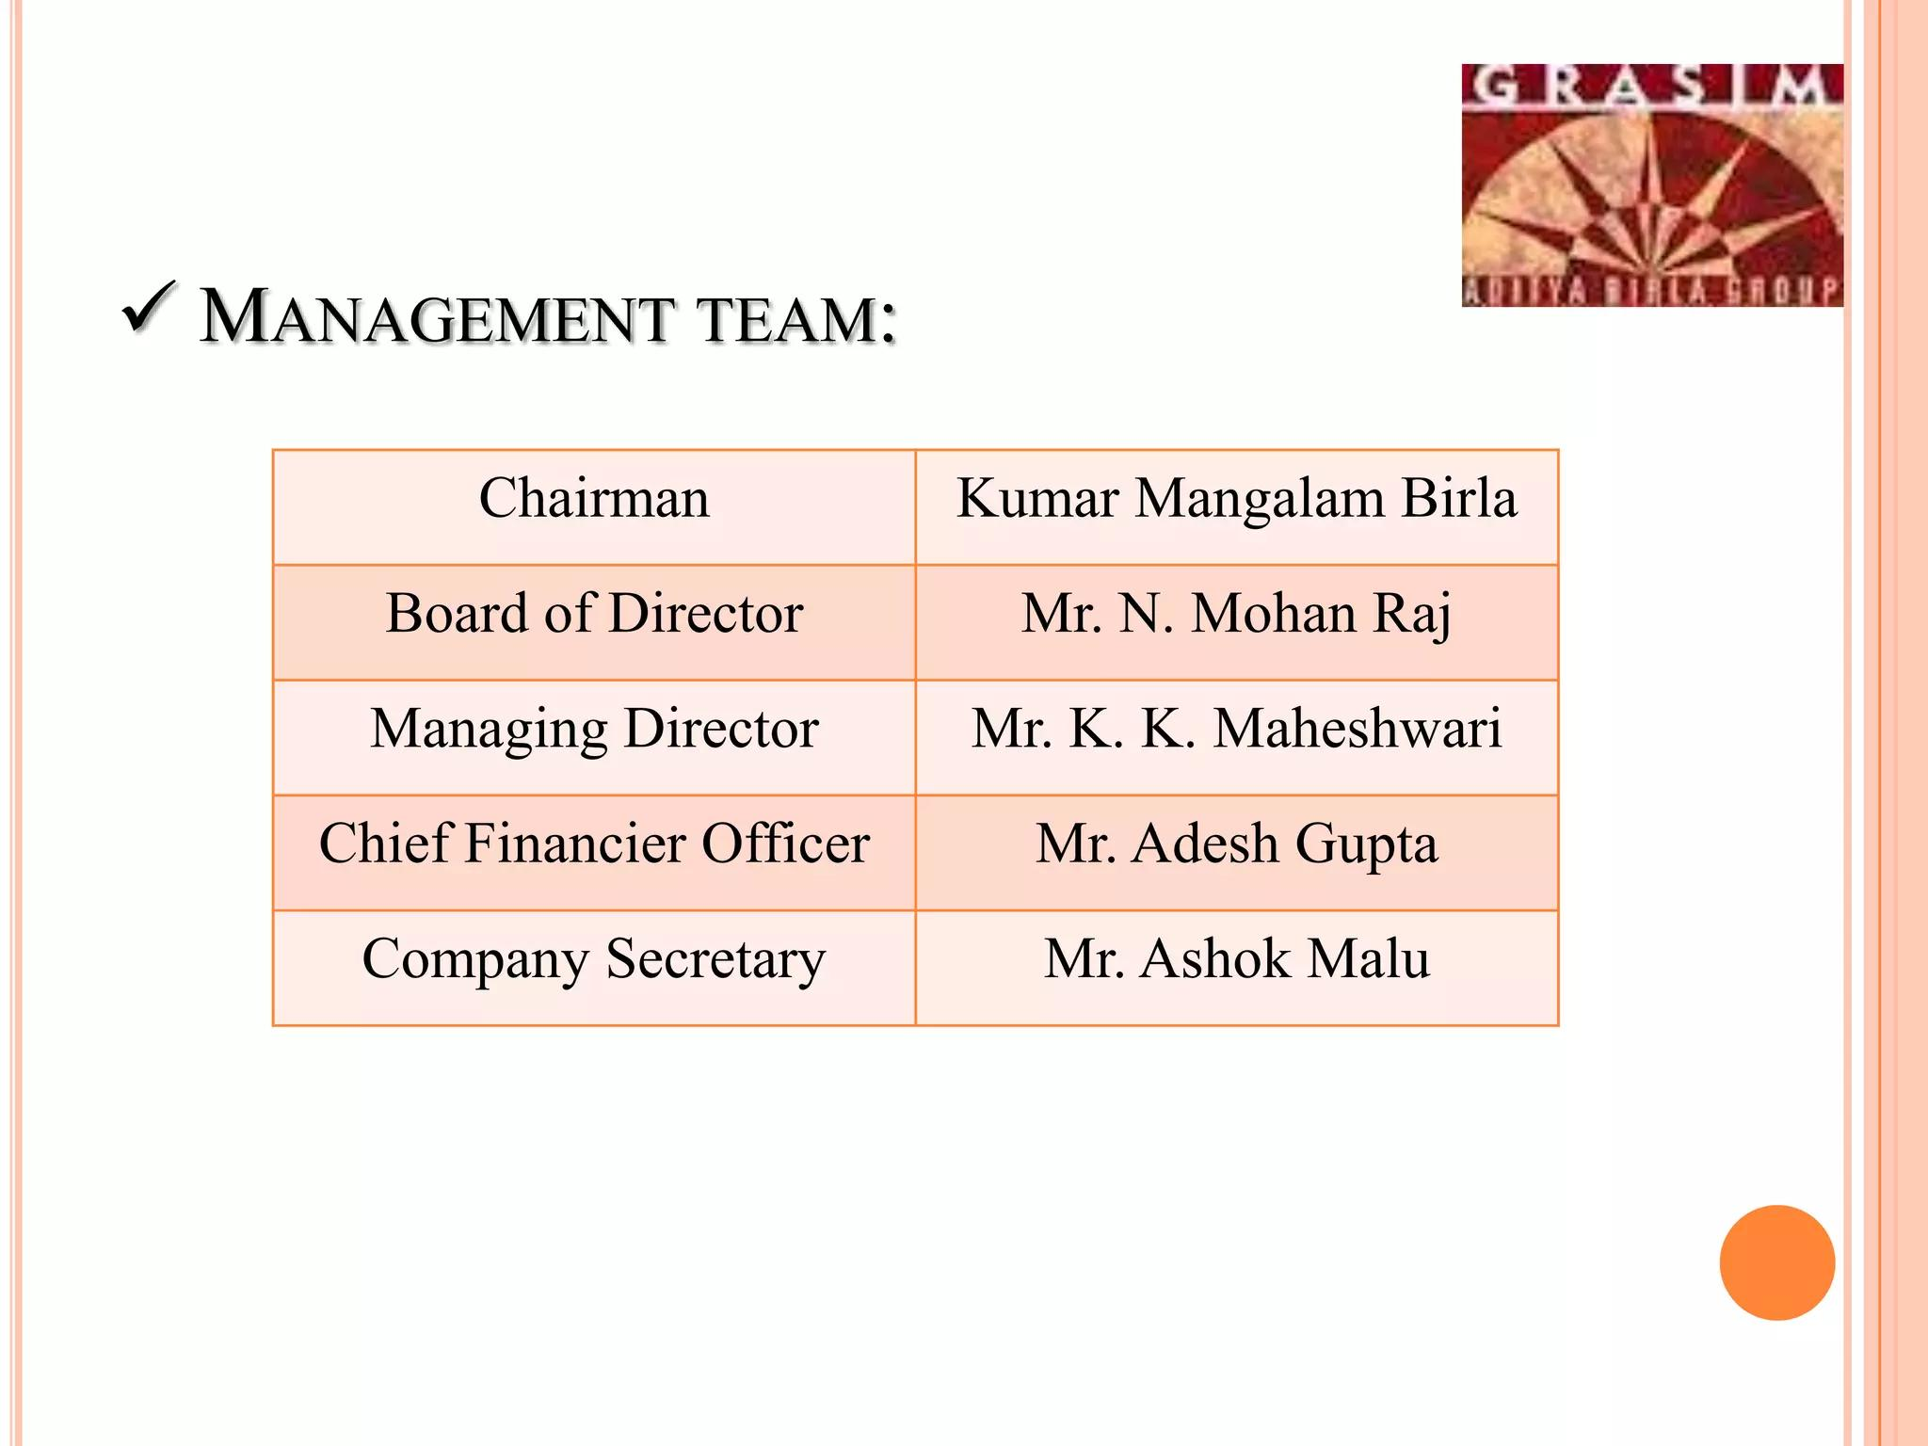
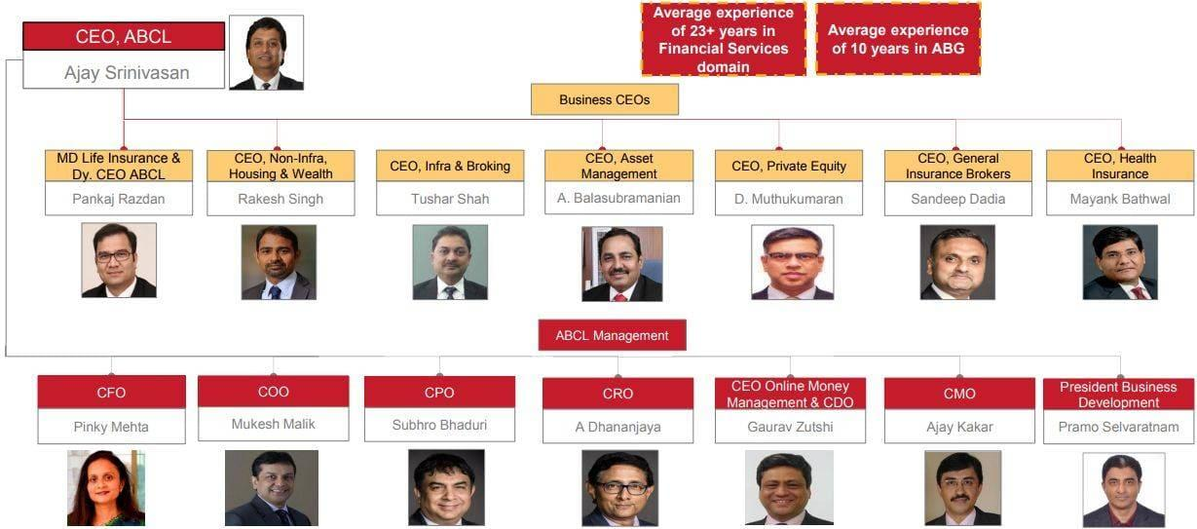
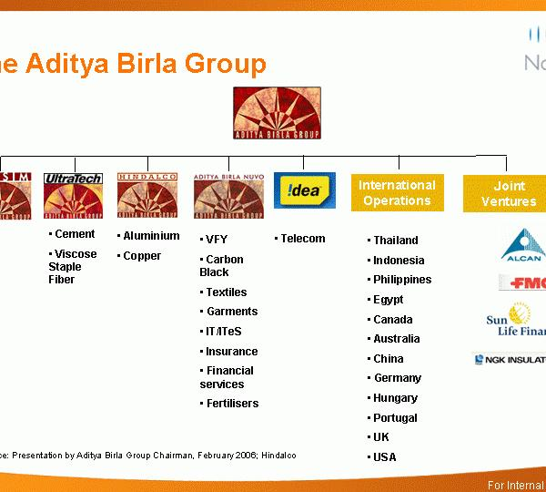
- Chairman: Kumar Mangalam Birla
- Group Strategy / Investment Committee
- Board-level oversight for ₹5,000 Cr investment
👉 Role:
- Decide entry into jewellery market
- Capital allocation
- Long-term positioning vs Titan / Reliance

🏢 2. Business Unit (Novel Jewels / Indriya Leadership)
This is the core execution layer
- CEO / Business Head (Novel Jewels) (not always publicly visible yet)
- Business Leadership Team

Key leaders:
- Marketing & Brand:
👉 Shantiswarup Panda
- Likely parallel roles:
  - Chief Merchandising Officer
  - Head of Retail Operations
  - Head of Supply Chain
  - Finance Head
👉 Role:
- Build Indriya as a brand
- Own P&L
- Drive expansion

🧩 3. Functional Leadership Layer

(This is where real execution happens)
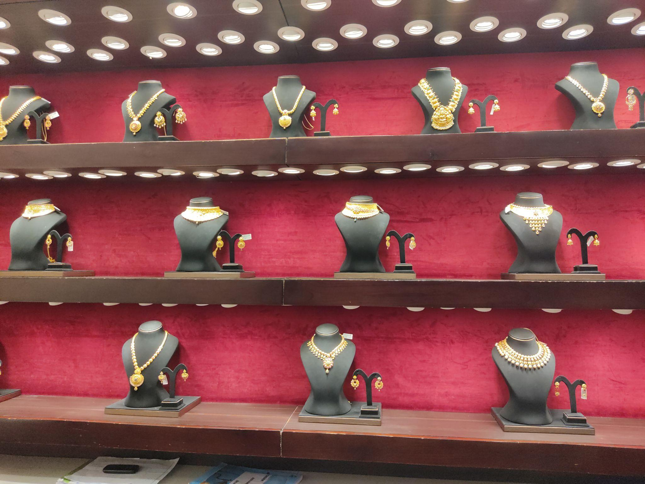
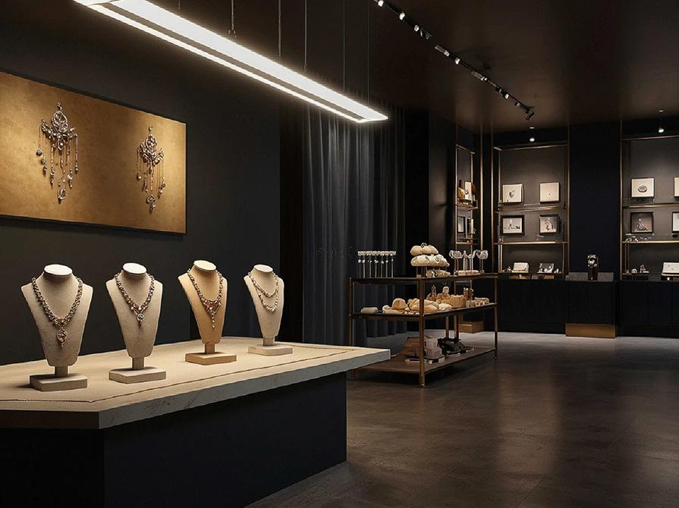
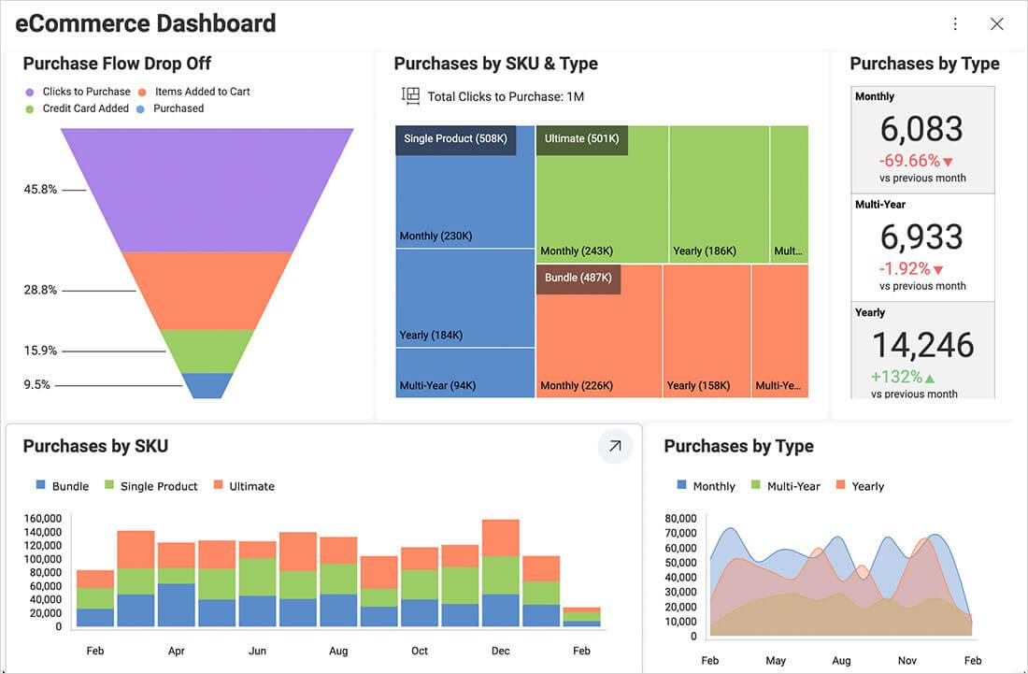
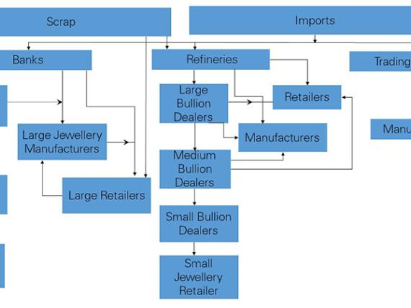

🔹 Marketing & Brand
- Campaigns, positioning, digital
- Owned by Panda

🔹 Merchandising & Product
- Jewellery design
- Pricing strategy
- Category mix (bridal, daily wear)

🔹 Retail Operations
- Store rollout
- Store performance
- Sales staff management

🔹 Supply Chain & Sourcing
- Gold procurement
- Diamond sourcing
- Vendor ecosystem

🔹 Customer & CRM
- Loyalty programs
- High-value customer tracking

🔹 Finance & Commercial
- Margins
- Cost control
- ROI on stores

🏬 4. Regional / Cluster Level
India is split into zones:
- North / West / South / East Heads
- Cluster Managers (city-level)
👉 Role:
- Execute store rollout
- Monitor performance region-wise

🛍️ 5. Store-Level Execution (Frontline)
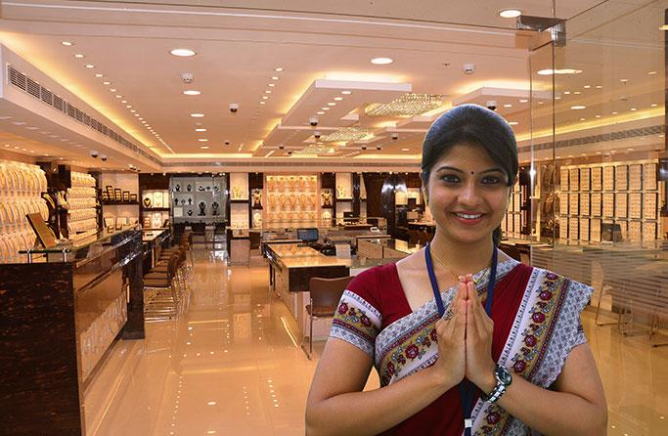
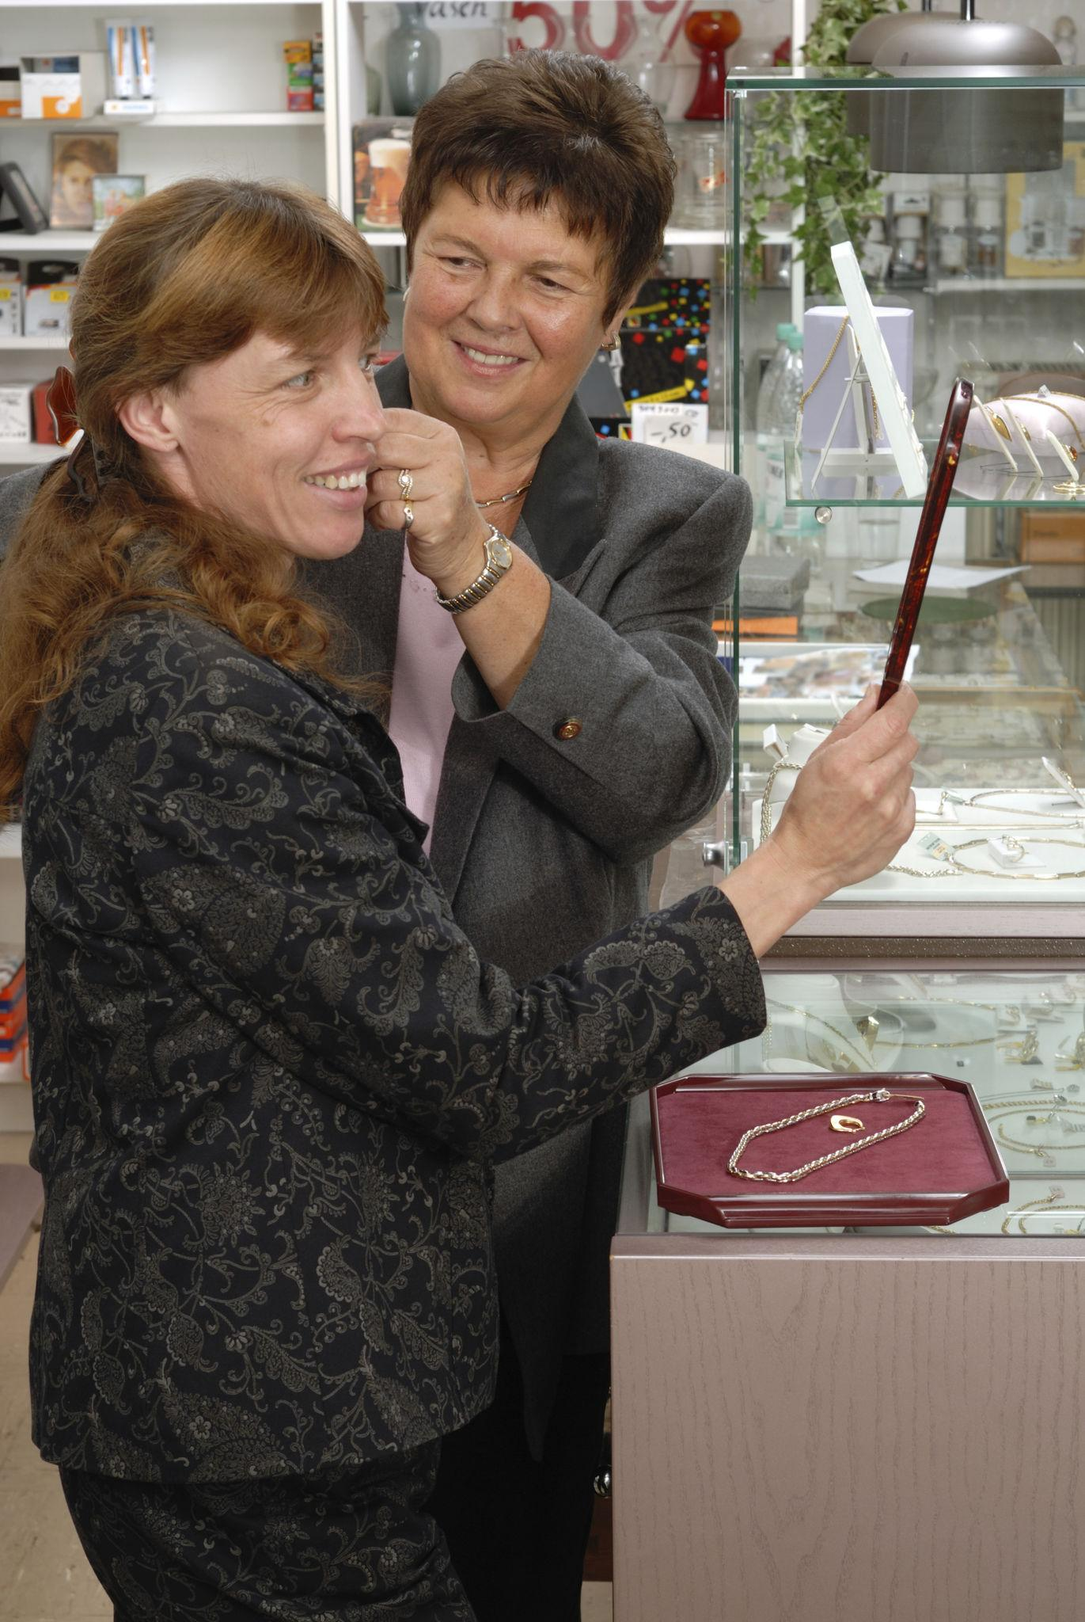

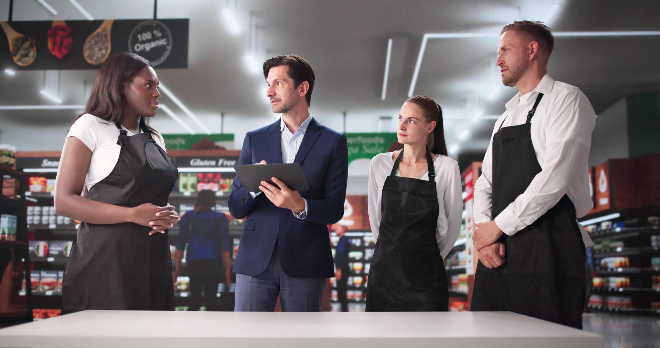
- Store Manager
- Sales Executives (relationship-driven selling)
- Visual Merchandising Executives
👉 Role:
- Convert walk-ins → purchases
- Deliver premium experience

🧠 How decision flow works (VERY IMPORTANT)
Chairman / Board
↓
Business Head (Novel Jewels)
↓
Functional Heads (Marketing, Retail, Supply, Merchandising)
↓
Regional Heads
↓
Store Managers
↓
Customers

⚡ Where Shantiswarup Panda fits
👉 He sits here:
Business Leadership Layer
↓
Head of Marketing & VM

His influence cuts across:
- Brand
- Store experience
- Customer journey
- Campaigns
👉 He works horizontally across all functions, not just marketing

🧩 Hidden Layer (Important)
Alongside hierarchy, there’s also:
- Agencies (marketing, design)
- Consultants (CRM, retail design)
- Vendors (gold, diamonds)
👉 These are not in hierarchy, but plugged into it

🔥 Key Insight (Critical for your understanding)
This is a “Retail + Luxury + FMCG hybrid structure”
Industry | What Indriya borrows
FMCG | GTM, branding (Unilever style)
Retail | Store ops, expansion
Luxury | Experience, trust

🚀 If you want next level
I can:
- Map exact org chart with roles + salaries + hiring pattern
- Compare Indriya vs Tanishq org structure
- Or show how you can enter at leadership level (your profile mapping)
Here is a clean, no-noise view of Novel Jewels (Indriya) hierarchy + objective + salary based on real data + industry structure.

🏗️ Novel Jewels (Indriya) — KEY HIERARCHY, OBJECTIVE & SALARY

🧭 1. Top Leadership (Business Head Level)
- CEO: Sandeep Kohli
- Director: Dilip Gaur

🎯 Objective
- Build Indriya into Top 3 jewellery brand in India in 5 years (FinCrif)
- Scale to pan-India retail chain
- Drive ₹5,000 Cr investment ROI

💰 Salary (Estimated)
- ₹1.5 Cr – ₹3 Cr+ (CEO level typical for large retail ventures)

🧠 2. Business Leadership Team (CXO / Functional Heads)
Example:
- Marketing Head → Shantiswarup Panda
- HR Head (GM HR)
- Supply Chain Head
- Merchandising Head
- Finance Head

🎯 Objective
- Own P&L of function
- Build:
  - Brand (marketing)
  - Store network (retail)
  - Supply chain (gold/diamond sourcing)
- Execute national rollout

💰 Salary (Actual data-backed range)
- GM HR: ₹53–57 LPA (Glassdoor)
- Senior Manager: ₹19–21 LPA (Glassdoor)
👉 Realistic range:
- ₹40 L – ₹80 L (CXO-1 layer)

⚙️ 3. Mid Management (Execution Owners)
Roles:
- Category Manager
- Store Expansion Manager
- Supply Chain Manager
- CRM / Martech Manager
- Production Planning Manager

🎯 Objective
- Execute:
  - Store rollout
  - Inventory planning
  - Demand forecasting
  - Process optimization (Trabajo.org)

💰 Salary
- ₹20 L – ₹30 L (NPI / Functional Managers) (Glassdoor)
- ₹6 L – ₹10 L (entry managers / SCM execs) (Glassdoor)

🏬 4. Retail & Regional Layer
Roles:
- Regional Manager
- Cluster Manager
- Store Manager

🎯 Objective
- Drive:
  - Sales per store
  - Customer experience
  - Conversion rate

💰 Salary (industry + proxy data)
- Store Manager: ₹4 L – ₹8 L
- Floor Manager: ~₹3 L – ₹5 L (similar jewellery retail benchmarks) (Indeed)

🛍️ 5. Store Frontline (Revenue Engine)
Roles:
- Jewellery Consultant / Sales Executive
- Cashier / Support staff

🎯 Objective
- Convert walk-ins → purchase
- Handle high-value customer relationships

💰 Salary
- ₹20K – ₹45K/month (WorkIndia)
- ~₹5 LPA (senior jewellery consultant) (Glassdoor)

📊 SUMMARY TABLE (what matters)
Level | Role | Core Objective | Salary
Top | CEO / Director | Build national brand | ₹1.5–3 Cr+
Leadership | Marketing, SCM, HR Heads | Own P&L, scale business | ₹40–80 L
Mid | Managers | Execute systems & rollout | ₹10–30 L
Retail Ops | Store/Regional Managers | Sales & store performance | ₹4–10 L
Frontline | Sales staff | Conversion & customer handling | ₹2–5 L

⚡ Key Insight (very important)
This hierarchy is designed for:
👉 Speed + Scale + Retail Execution
- Top → Strategy
- Middle → Execution engine
- Bottom → Revenue generation

🔥 One-line understanding
👉 Novel Jewels is a retail war machine structure, not a consulting-driven org.

If you want next step, I can:
- Map who controls power (real influence vs title)
- Or compare Indriya vs Tanishq org + salary differences
Got it — you want very clear clarity on “Own P&L + scale business” specifically for the leadership team at Novel Jewels (Indriya).
Let’s break it like an operator (not theory) 👇

🧠 Leadership Team @ Novel Jewels — REAL OBJECTIVE
(For people like
👉 Shantiswarup Panda and other functional heads)

🎯 1. “Own P&L” — What it ACTUALLY means
👉 P&L = Profit & Loss responsibility

They are accountable for:

💰 Revenue (Top Line)
- Total jewellery sales (gold + diamond)
- Revenue per store
- Conversion rate (walk-ins → buyers)

💸 Cost (Bottom Line)
- Store rent (prime locations = expensive)
- Gold procurement cost
- Marketing spend
- Staff salaries

📈 Profit (Final Output)
- Margin per product
- Overall business profitability

🔥 Simple equation they manage:
\text{Profit} = \text{Revenue} - \text{Cost}
👉 If profit drops → leadership is accountable
👉 If profit grows → leadership wins

🚀 2. “Scale the Business” — What it REALLY means
Not just growth — controlled, profitable expansion

🏬 A. Store Expansion
- Open new stores in:
  - Tier 1 cities (Mumbai, Delhi)
  - Tier 2 (wedding-heavy markets)
👉 Goal:
- Increase retail footprint

📊 B. Increase Revenue Density
- Revenue per sq. ft.
- Revenue per store
👉 Not just more stores — better performing stores

👥 C. Customer Scaling
- Acquire new customers
- Retain high-value buyers (wedding segment)

🧠 D. Brand Scaling
- Build trust vs competitors like
Titan Company (Tanishq)

⚙️ E. System Scaling
- CRM systems
- Supply chain
- Inventory management
👉 Without systems → scaling breaks

🧩 3. Leadership Team — FUNCTION-WISE OBJECTIVE

🎨 Marketing Head (Panda)
- Drive demand
- Build brand trust
- Improve conversion
👉 KPI:
- Customer acquisition cost
- Brand recall
- Campaign ROI

📦 Supply Chain Head
- Ensure gold/diamond availability
- Optimize inventory cost
👉 KPI:
- Inventory turnover
- Cost efficiency

🏬 Retail Head
- Ensure stores perform
👉 KPI:
- Sales per store
- Conversion rate
- Customer experience

💰 Finance Head
- Control cost
- Ensure profitability
👉 KPI:
- EBITDA
- Margin %

💍 Merchandising Head
- Decide product mix
👉 KPI:
- Sell-through rate
- Product margin

🔄 4. How they work together (REAL FLOW)
Marketing → brings customers
↓
Retail → converts customers
↓
Merchandising → provides right products
↓
Supply Chain → ensures availability
↓
Finance → tracks profitability
👉 If ANY layer fails → P&L suffers

⚡ 5. What makes this role powerful
They are NOT:
❌ Department managers
They ARE:
✅ Mini-CEOs of their function

🔥 Real Example (Indriya scenario)

Situation:
Sales are high, but profit is low

Leadership action:
- Marketing reduces discount-heavy campaigns
- Supply chain negotiates better gold sourcing
- Merchandising pushes higher-margin products
👉 Result:
- Profit improves without reducing sales

🧭 Final One-Line Understanding
👉 Leadership team at Novel Jewels =
“Own profit + grow business + ensure system works end-to-end”

If you want next level clarity, I can break:
- Exact KPIs dashboard used by leadership (daily/weekly metrics)
- Or simulate how a CXO reviews business every Monday (real playbook)
Got it — you want a clean, leader-level breakdown (one by one) of:
👉 Objective + P&L responsibility for each key role in Novel Jewels (Indriya)
Let’s do this like a real org review deck 👇

🏗️ Novel Jewels (Indriya) — LEADERSHIP OBJECTIVES + P&L

1️⃣ Business Head / CEO

🎯 Objective
- Build Indriya into a national jewellery brand
- Scale stores + revenue + brand trust
- Compete with Titan Company (Tanishq)

💰 P&L Ownership
- Full P&L (end-to-end)
  - Revenue (all stores)
  - Cost (marketing, rent, sourcing, salaries)
  - Profit (EBITDA)
👉 Final accountability = total business profit

2️⃣ Marketing Head
👉 Shantiswarup Panda

🎯 Objective
- Build brand + demand
- Drive footfall & customer acquisition
- Create premium perception

💰 P&L Ownership
- Revenue influence + Cost control
  - Drives revenue via campaigns
  - Controls marketing spend
👉 KPI:
- Revenue generated per ₹ spent (ROI)

3️⃣ Retail Operations Head

🎯 Objective
- Ensure stores convert customers
- Deliver premium in-store experience
- Maximize sales per store

💰 P&L Ownership
- Revenue + Store cost
  - Store sales
  - Staff cost, store operations cost
👉 KPI:
- Sales per sq ft
- Conversion rate

4️⃣ Merchandising Head

🎯 Objective
- Decide:
  - Product mix (bridal, daily wear)
  - Pricing strategy
- Maximize margin per product

💰 P&L Ownership
- Margin control
  - Product pricing
  - Gross margin
👉 KPI:
- Sell-through rate
- Margin %

5️⃣ Supply Chain / Sourcing Head

🎯 Objective
- Ensure:
  - Gold & diamond availability
  - Efficient procurement
- Optimize inventory

💰 P&L Ownership
- Cost control
  - Raw material cost
  - Inventory holding cost
👉 KPI:
- Inventory turnover
- Procurement cost

6️⃣ Finance Head

🎯 Objective
- Ensure profitability & financial discipline
- Track all cost + revenue

💰 P&L Ownership
- Full financial control
  - Budgeting
  - Profit tracking
  - Cost optimization
👉 KPI:
- EBITDA
- Net profit

7️⃣ HR Head

🎯 Objective
- Build high-performing retail teams
- Hire + retain sales talent

💰 P&L Ownership
- Indirect cost control
  - Salary cost
  - Productivity
👉 KPI:
- Revenue per employee
- Attrition rate

8️⃣ CRM / Customer Experience Head

🎯 Objective
- Build loyalty & repeat customers
- Manage high-value buyers (wedding segment)

💰 P&L Ownership
- Revenue retention
  - Repeat purchase revenue
  - Customer lifetime value
👉 KPI:
- Repeat rate
- Customer lifetime value

📊 FULL P&L FLOW (how all leaders connect)
Revenue Drivers:
Marketing → brings customers
Retail → converts to sales
CRM → retains customers

Margin Drivers:
Merchandising → pricing & mix
Supply Chain → sourcing cost

Profit Control:
Finance → monitors everything

⚡ FINAL SIMPLIFIED VIEW
Role | Objective | P&L Responsibility
CEO | Build & scale business | Full P&L
Marketing | Demand & brand | Revenue + marketing cost
Retail | Store performance | Revenue + store cost
Merchandising | Product & pricing | Margin
Supply Chain | Procurement | Cost
Finance | Profit control | Full financials
HR | Team productivity | Cost efficiency
CRM | Customer retention | Repeat revenue

🔥 ONE-LINE INSIGHT
👉 Each leader owns one part of P&L,
👉 CEO owns entire P&L

If you want next level, I can:
- Show actual KPI dashboard (daily metrics CXOs track)
- Or simulate real monthly business review meeting (who says what, decisions taken)

